**1.** $_SESSION superglobal is used to set and get the session variables. However, why is it so that in the case of cookies, setcookie() method is used to set cookie data while the $_COOKIE superglobal is used to retrieve that data. Provide reasons.

**Answer:** In simple terms $_SESSION and $_COOKIE are different. Both are PHP super global but cookies are used without a language limitation. $_SESSION is all about storing the data in the server while storing the session ID as a cookie. $_COOKIE is the cookies that browser sends to the server.

setcookie() prepares a cookie to be sent with the server response to the client. The $_COOKIE array is populated only when the Client sends a request.

**2.** Turn off cookie propagation in php.ini setting and turn on the url propagation for the session id. Use sessions and observe (display output) how session id is being propagated between pages. What happens when both the settings are turned on in php.ini file? How will the session id get propagated then?

**Answer:** If session.use_cookies = 0 In this case session does not store sessionId into cookie and you will get each time a new sessionId using session_id() and data stored into session on other pages will not be found on another pages. Yes session will work when cookies is disabled. But first apache check php configuration settings. Like: session.use_trans_sid = 1 if these value are set true the session will passed by POST automatically.

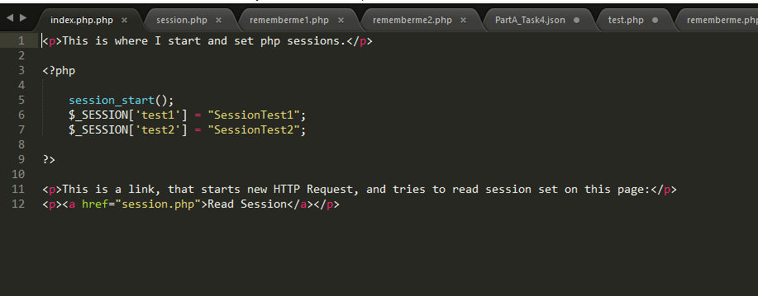

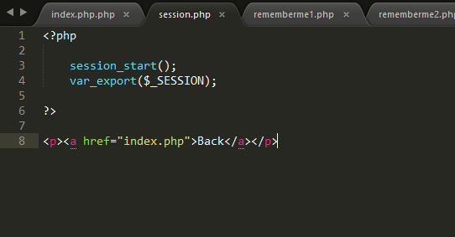

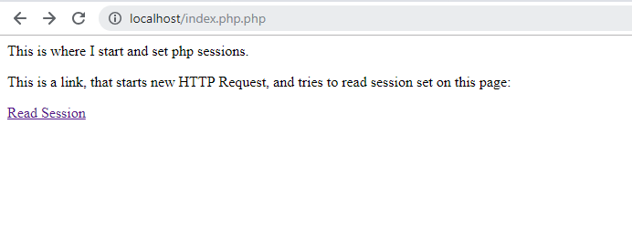

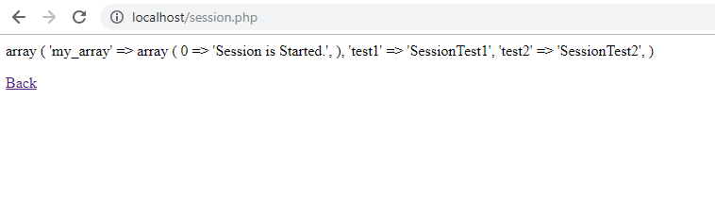

And when both propagation modes are turned on, then session id will propagate by the default way i.e. using cookies.